**Cured – User Manual**

Overview of Software:

“Cured” is a mobile application that allows users to monitor and schedule a medicine intake that will be displayed in a calendar-like widget and send out push-notifications.

These push-notifications help remind the user to take their scheduled medicines. Medicines can be edited and removed.

Other features include a Diary Entry system that allows the User to record how they are feeling. There is an instructions page so Users can get an understanding on how to use the app as well.

Hardware Requirements:

The Hardware requirements are:

* An Android Phone
* Internet connection

How to install the software:

To install the software the user needs to download Android Studio with the following link:

<https://developer.android.com/studio>

Then the user needs to install Android Studio following the steps provided with the download. After launching Android Studios, the user needs to click on:



Then Git. And use the following URL:

<https://github.com/WuTangDecClan/Cured>

–Then click “Yes”. 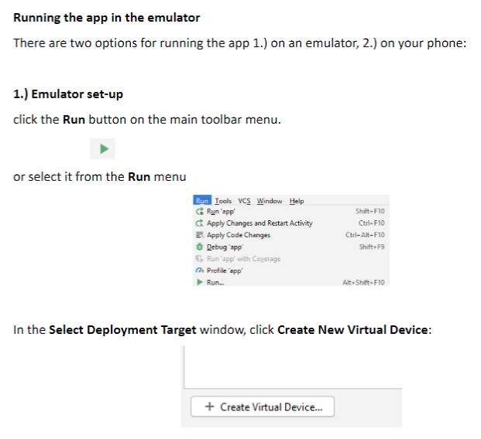

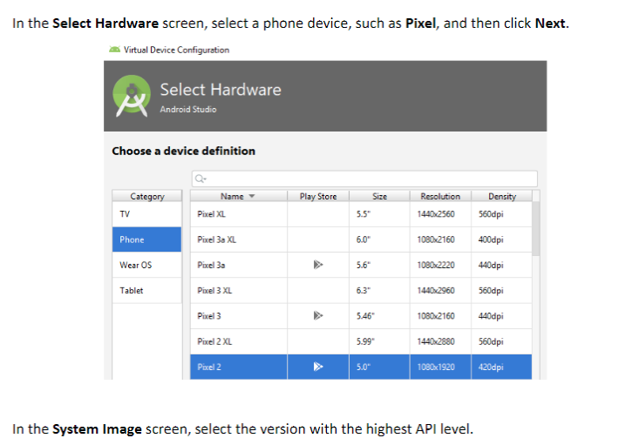

How to run the software:

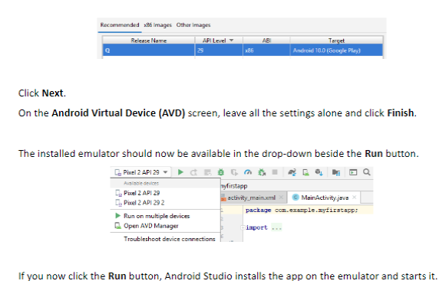

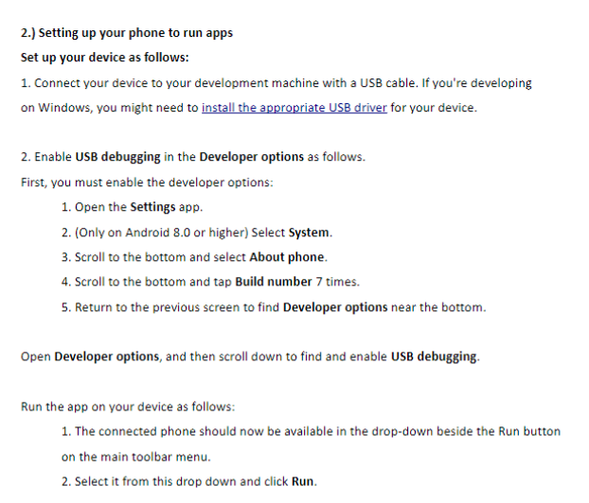

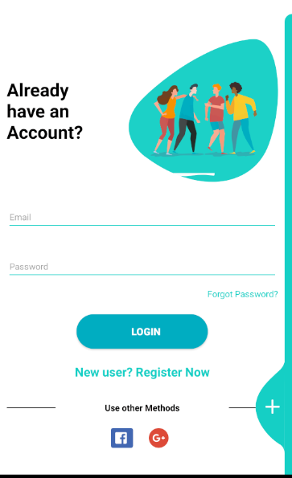

How to use the software:

To Login just put in your email and password and then hit login. You can also use social logins with Facebook and the Google Plus buttons down below.

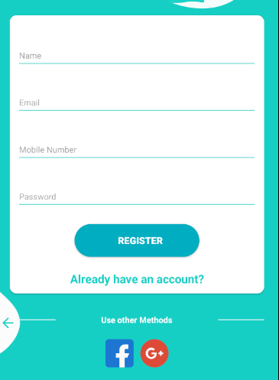

If you need to Register as a new User, then hit the + button on the right-hand side and you will be taken to the create a profile page. You can also use Social Login here, if you need to return just hit the back arrow at the bottom left of the screen.

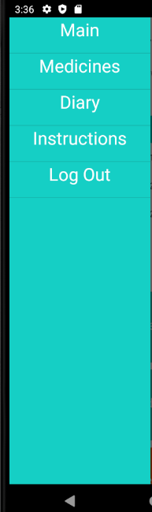

To get the main menu up just simple slide your finger from left to right.

To get started, we will look at the Main Menu. From the top you see MAIN. Tapping on this will bring you back to the main screen of the calendar and medicines.

Next is New Medicine. Tapping on this will bring you to creating a new medicine with simple instructions.

Below is Diary List and New Diary these will bring you to viewing and creating Diary entries.

Finally, log out will log your account out of the app and forth between months using the arrow signs. Then you can tap on any day, when selected it will become highlighted.

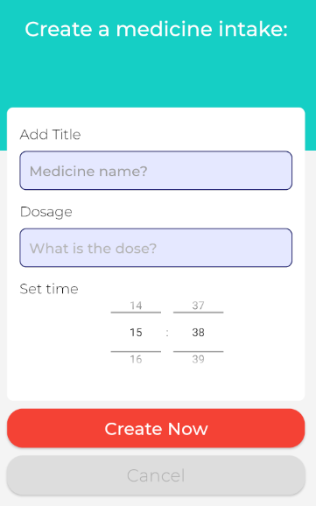To add a new medicine, click the Red circle with the plus inside of it. Once a medicine is added it is visible near the bottom of the screen.

Now you can add a new Medicine by filling out the form and clicking on “Create Now”. If you are not happy, you can always hit “Cancel”, and this will bring you back to the main screen.

To go to the Diary Page just go by the Menu or click the appropriate box. Once there you can hit plus to add a new diary entry of you can view ones already created. It follows the same methods as adding a new medicine and is self-explanatory.

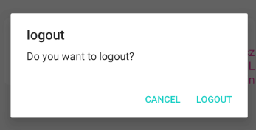

How to quit:

To quit just go to the menu screen again and hit Log Out and hit “Logout” again.